Research for Intel® vPro™ development platforms
intelliPATH Consulting Private Limited

5/23/2012

Proprietary Notice
Statement of Purpose and Use

Information contained in this document is intended solely to provide information necessary for recipient for the proposal. Under no circumstances shall any information contained in this document be deemed to be incorporated into any contract or legal agreement without the express, written consent of an officer of intelliPATH Consulting Private Limited.
In consideration of receipt of this document, the recipient agrees to maintain such information in confidence and to not reproduce or otherwise disclose this information to any person other than those employees of recipient directly responsible for evaluation of its contents.
However, there is no obligation to maintain the confidentiality of any information, which was rightfully known to the recipient prior to receipt of such information from IPCL, becomes publicly known through no fault of recipient, or is received by recipient from a third party not under obligation to keep such information confidential.

This data, furnished in connection with this proposal, shall not be disclosed outside recipient. and shall not be duplicated, used, or disclosed in whole or in part for any purpose other than to evaluate the proposal; provided, that if a contract is awarded to this offer or as a result of or in connection with the submission of this data. Recipient shall have the right to duplicate, use, or disclose the data to the extent provided in the contract. This restriction does not limit recipient the right to use information contained in the data if it is obtained from another source without restriction.

© 2012 intelliPATH Consulting Private Limited
Noida, UP

All rights reserved. No part of this publication may be reproduced by any means without written permission from IPCL.

IPCL will also maintain the confidentiality of Technical and Process Information shared by the client.

All questions regarding this proposal should be routed through:
E-mail: sales@intelliPATH.co.in
Post: Director
418, F30, Sector 50,
NOIDA - 201301, INDIA
Website: intelliPATH.co.in

Table of Contents

1 Current Situation 5
2 Background 5
2.1 Platform options 5
Fig 1: Various options in S/W development platform 6
2.2 Explanation of fig 1 6
3 Comparison 7
4 Recommendations 8
4.1 Assumptions 8

Proposal
intelliPATH is a consulting company operating in IT& Marketing sectors primarily. The company is founded by post-graduates from IIT & IIM with a vision to create a new wave of learning.

Current Situation
Client is looking for information to support its decision regarding which programming platform to use for programming Intel’s vPro technology to address the issues around PC management in a cost effective & efficient manner.

Background
Intel vPro technology addresses two critical issues in the PC world, namely
- Manageability
- Security
for the purpose of this document, the aspect of security is not considered.
For this reason a special focus if given to Client to utilize Intel Active Management Technology.
Intel AMT is a capability embedded in Intel-based platforms that enhances the ability of IT organizations to manage enterprise computing facilities. Intel AMT operates independently of the platform processor and operating system. Remote platform management applications can access Intel AMT securely, even when the platform is turned off, as long as the platform is connected to line power and to a network.
Independent software vendors (ISVs) can build applications that take advantage of the features of Intel AMT using the application programming interface (API).

Platform options
Intel vPro processor technology uses an integrated software & hardware architecture which improves remote problem diagnostics and repair.

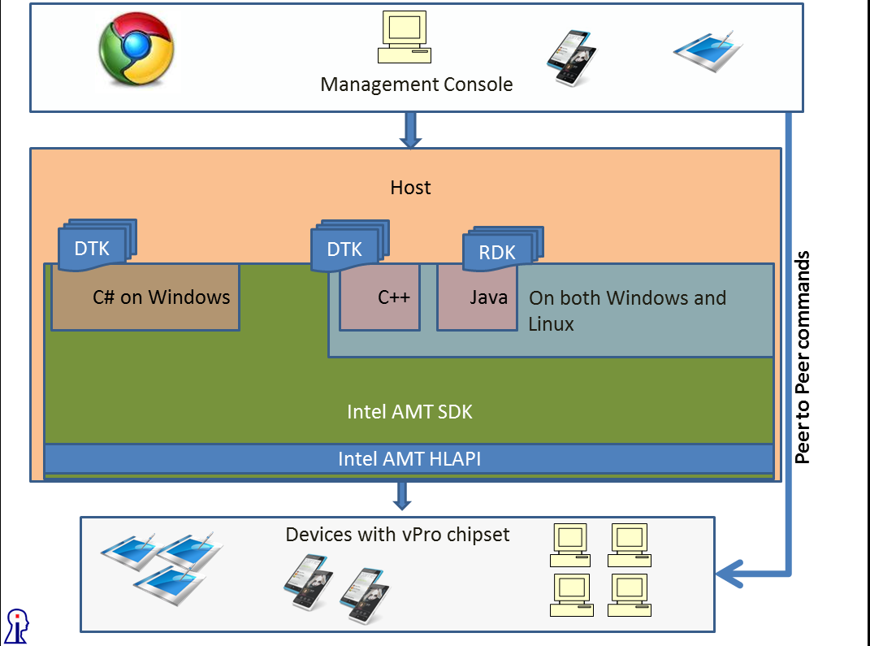

Fig 1: Various options in S/W development platform

Explanation of fig 1
The AMT client once ready* can receive commands from host. The AMT client on a device could be found in two ways:
- It could be a part of Peer to Peer or routable network.
- It could be accessible through a server.
Further the diagram mentions the usage of 3 primary languages C++, C# and Java for programming.
Developer’s Tool Kit (DTK): Intel provides a comprehensive listing of samples in C#/C++ for AMT
Reference Tool Kit (RDK): Intel provides a comprehensive listing of samples in Java. These are old and are no longer being updated by Intel.
Intel provides HLAPIs (High Level APIs) and a comprehensive SDK for use by developers. SDK is available both in Linux & Windows.

_______________________________________________________________________________
*Ready here means that Intel’s setup & configuration system is already used to enable & configure vPro on clients

Comparison
A rough poll done at Intel site shows C# is the choice of developers but if we add Java for both Windows and Unix OS, Java is not far behind. The fact is surprising since Java is not so well supported by Intel.
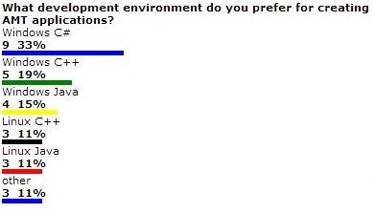
Fig 2: Poll result of developer’s choice of language

Another piece of interesting data is the number of downloads of various toolkits over the period of an year
AMT SDK (primarily C# & C++) | 920
Manageability DTK (C#) | 8
AMT RDK (Java) | 94
Fig 3: No of downloads, toolkit wise

It is clear that C#, C++ is the winner but Java’s number of downloads for Reference Tool Kit is interesting. RDK has not been updated since AMT release 2.0 and is the only authentic source of help for Java Developers.

With Java and C++, the main advantage is that they can run on both Linux and Windows. With C#, we are restricted to a windows based host – however in terms of the number of templates, code samples and overall eco system – Intel provides excellent support for C# & Windows.

AMT is really OS agnostic, in fact it works without OS and without Power being on. The case-in-point then remains that what is the customer’s context and accordingly decide the choice of language.

Recommendations
intelliPATH recommends using C# as the programming language for using Intel AMT technology on vPro platform. The primary differentiating reasons for this recommendation are:
- An up-to-date and ready reference availability for developers
- Intel is not providing necessary developer enablement for Java
- vPro chipset lies before the OS, a software developed on Windows platform can still be able to control the different devices with vPro chipset which may be on different OS like Linux, Windows or Android.

Assumptions
The research done by intelliPATH is for executive reading and results are further abstracted in this document with a specific purpose. The facts and recommendations have to be understood along with the context.

